Course Name: | Elements of Electrical and Electronics Engineering | Semester: | I/II
Date of Performance: | 23/11/21 | Batch No: | A2
Faculty Name: | Maruti Zalte | Roll No: | 16010121045
Faculty Sign & Date: |  | Grade/Marks: | / 25

Experiment No: 3

Title: Thevenin’s Theorem & Norton’s Theorem.

Aim and Objective of the Experiment:
- To Verify for Thevenin’s Theorem for the circuit
- To Verify Norton Theorem for the Circuit.

COs to be achieved:
CO1: Analyze resistive networks excited by DC sources using various network theorems.
.

Circuit Diagram/ Block Diagram:
Circuit Diagram
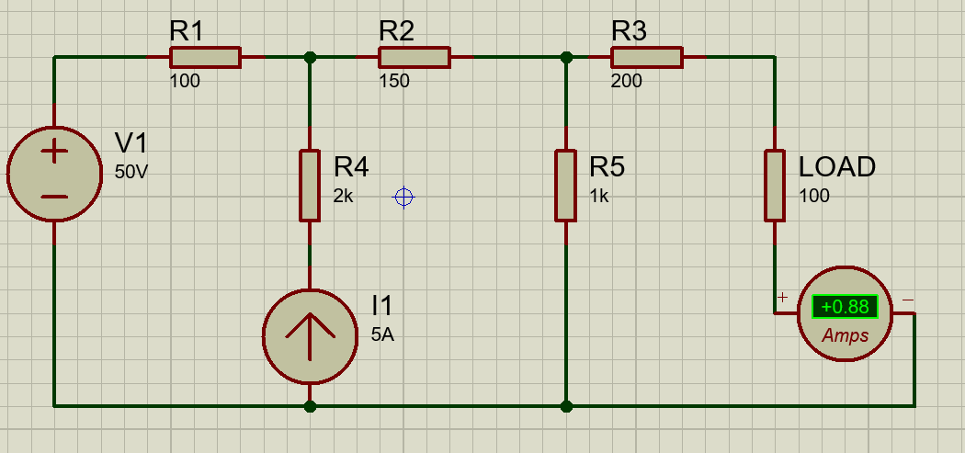
Pargat Singh

Task 1: Circuit Diagram to measure V_{Th:}
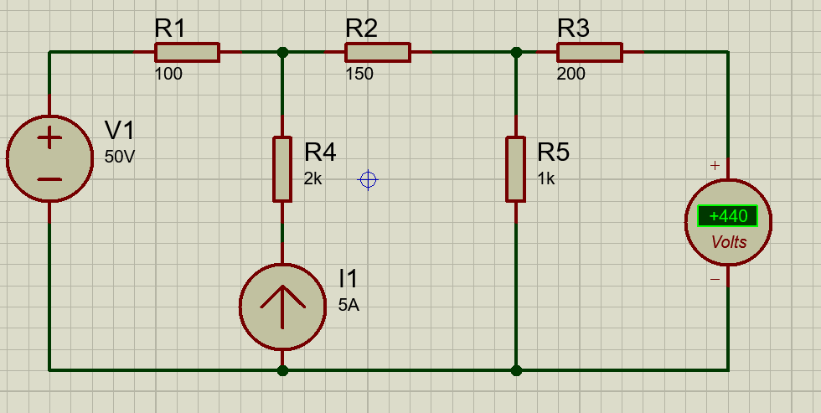
Pargat Singh

Task 2: Circuit Diagram to measure Isc=I_{N:}
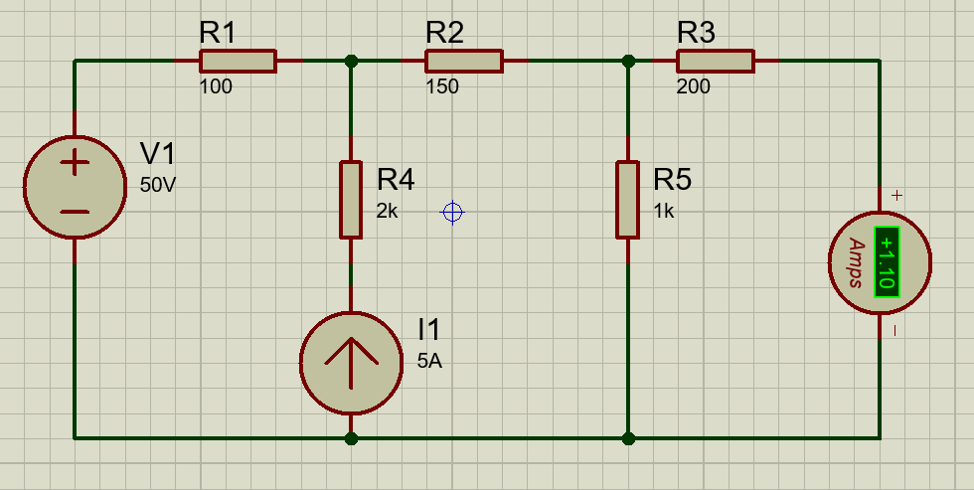
Pargat Singh

Task 3: Circuit Diagram to measure Rth=R_{N:}
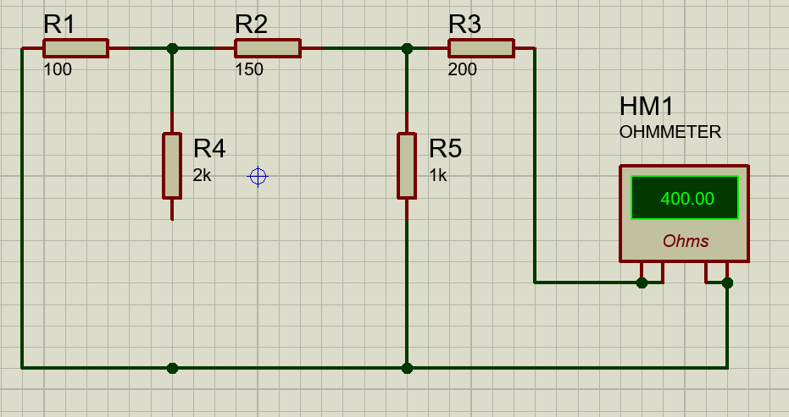
Pargat Singh

Stepwise-Procedure:
Thevenin’s Theorem
1. Connect the circuit as shown in the circuit diagram.
2. Set V1, V2 and measure open circuit voltage V_{Th} across load terminals A and B.

3. Replace all voltage sources by Short circuit and measure R_{Th} across terminals A and B as per the circuit diagram shown in the figure.
4. Draw Thevenin’s equivalent circuit and determine the value of load current from it.
5. Verify the results theoretically.

Norton’s Theorem
1. Connect the circuit as shown in the circuit diagram.
2. Set the voltages V₁, V₂
3. Remove the load resistance and measure the short circuit current I_{SC} through A and B terminals.
4. Replace all the voltage sources by Short circuit and measure R_{Th} across terminals A and B as per the circuit diagram shown in the figure.

5. Draw Norton’s equivalent circuit and determine the value of load current.
6. Verify the results theoretically

Observation Table:
 | I_{RL}
Practical value | 0.88 A
Theoretical value | 0.88 A

 | Vth | Rth (Ω) | Isc (I_{N}) | I_{rl}  _{Thevenin} | I_{rl ΩNorton}
Practical value | 440 V | 400 | 1.10 A | 0.88 A | 0.88 A
Theoretical value | 440 V | 400 | 1.10 A | 0.88 A | 0.88 A

Thevenin’s equivalent circuit  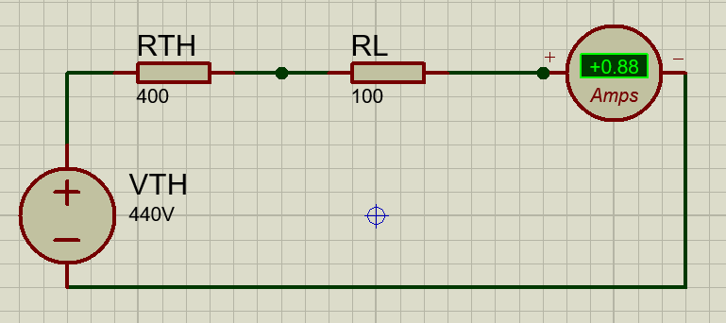  Pargat Singh | Norton’s Equivalent Circuit  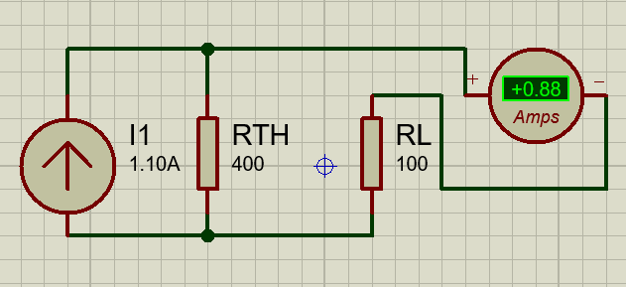  Pargat Singh

Theoretical Calculation:
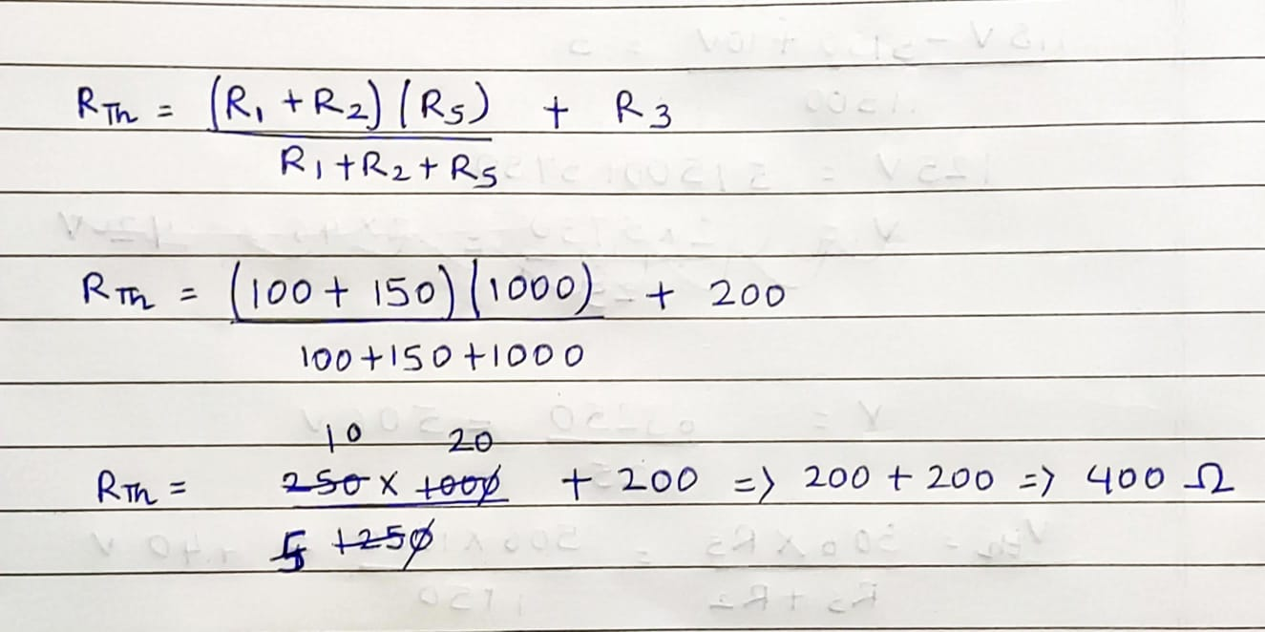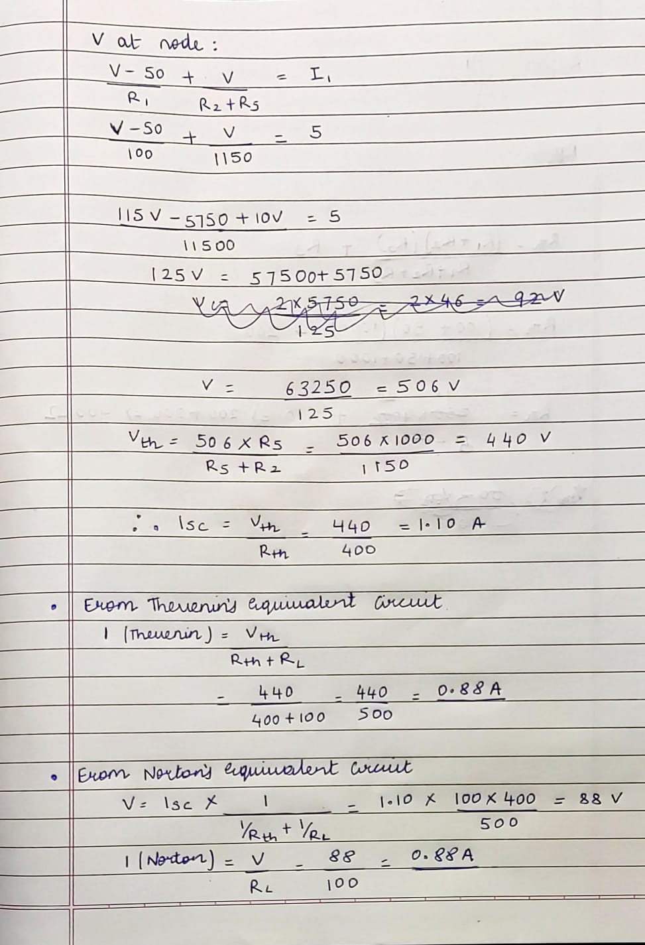

Conclusion:
We can solve any complex circuit by applying Thevenin’s or Norton’s Theorem. By performing the experiment, we can verify both theorems.

Signature of faculty in-charge with Date:

